Assignment 11
Section 1: Pen-and-paper Exercises

- Below is the pseudocode for Quicksort and Partition that we talked about in class. As usual with recursive functions on arrays, we see the array indices s and e as arguments. Quicksort(A, s, e) sorts the part of the array between s and e inclusively. The initial call (that is, to sort the entire array) is Quicksort(A, 0, n − 1).

QuickSort(A, s, e)
if s < e
p = Partition (A, s, e) // Partition the array and return the position of pivot after the partition
QuickSort(A, s, p-1) // Sort left side
QuickSort (A, p+1, e) // Sort right side
end if

Partition(A, s, e)
pivot = A[s], i = s + 1, j = e; // Let the leftmost element be the pivot
while i<=j // Rearrange elements
while i < e & A[i] < pivot,
i = i + 1
end while
while j > s & A[j] >= pivot,
j = j - 1
end while
if i >= j
break
end if
swap A[i] nd A[j]
end while
swap A[s] nd A[j]
return j; // Return the index of pivot after the partition

- Let A = {11, 7, 6, 48, 30, 12, 75}, and assume we call Quicksort(A, 0, 6). Show what happens during the first invocation of Partition. What is the value of p returned, and what are the two recursive calls made?
Note: Credit will not be given only for answers - show all your work:
(5 points) steps you took to get your answer.
(2 points) your answer.
Ans:
A = {11, 7, 6, 48, 30, 12, 75}
Quicksort(A,0,6), s = 0, e = 6
→Partition (A,0,6)
After Partition, the array looks like:
{6, 7}, 11, {48, 30, 12, 75}
Index: 0, 1, 2, 3, 4, 5, 6, 7
And Partition returns 2, which is the index of the pivot 11 in the array
There will be 2 recursive calls on the left and right subarray
The left array starts at index 0, ends at index 1
The right array starts at index 3, ends at index 7
Quicksort(A, 0, 1) // left array
Quicksort(A, 3, 7) // right array

- How do you modify Partition(A, s, e) so that it chooses the pivot as the median of three elements randomly selected from the array?
(5 points) pseudocode to change Partition.

Ans:
r1, r2, r3 = random(s, e)
pivot = median(r1, r2, r3)
swap(A[s], A[pivot])
then the original partition algorithm

- How do you modify Partition(A, s, e) so that it always chooses the pivot uniformly at random from the array (instead of shuffling the array initially)?
(5 points) pseudocode to change Partition.
Ans:
pivot = random(s, e)
swap(A[s], A[pivot])
then the original partition algorithm

- Suppose we want to make change for N cents, using the least number of coins of denominations {1, 5, 10} cents (Different from the US currency system!). Consider the following greedy strategy: suppose the amount left to change is M, take the largest coin that is no more than M; subtract this coin's value from M, and repeat.
Does this algorithm output an optimal solution? If not, give a counterexample. If yes, prove that this algorithm always outputs an optimal solution (a formal proof as what we have done in the video).
Proof:

Let a be the number of coins worth 10 cents taken by the greedy algorithm, let b be the number of coins worth 5 cents, and c be the number of coins worth 1 cent.

Assume the solution a, b, and c given by the greedy algorithm G is not optimal.
Assume the optimal solution O gives a', b', c'.

First, let's look at a and a' ( the number of 10-cent coins)
- a < a', not possible
- a > a', thus a' at most = a-1, then at least there are 10 cents to make up using {5, 1} , which is 2 coins worth 5 cents, included in b'. Then let's create a new solution O’:
a'+1, b'-2, c' →
Therefore O’ uses a‘ + b‘ + c‘ -1 coins, uses 1 coin less than the optimal solution a' + b' + c' --> contradiction, the optimal solution O different from G should not exist, otherwise, we can always create a new solution O’ that uses less coins
3. a = a', continue to look at b and b', will reach a contradiction eventually (similar to the second case)
As a result, either O does not exist, or if it exits, must be the same as G.
G is the optimal solution. Q.E.D

- Consider the knapsack problem.
A thief enters a store and sees n items, each item i has value vi, size si. His knapsack is of size S
What items should he put into the knapsack to maximize profit?
Assume we have n = 3 items, and a bag of size S = 5.

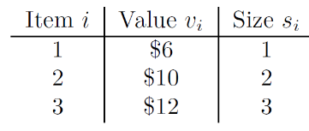

a)
In fractional knapsack problem, the thief can take a fraction of an item and put it into his knapsack. To solve the problem, we can use the following greedy algorithm:

- Compute di = vi/si for each item

- Sort each item by their value di.

- Take as much as possible of the highest di item not already in the bag

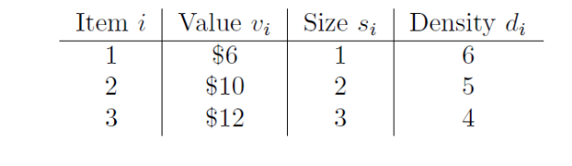
Given the algorithm and the items above, which item(s) will you put into the knapsack? What is the total value of your knapsack? (5 points)
Greedy algorithm chooses: items 1, 2, and 2/3 of item 3 for a total value of 24
Optimal solution: the same as the greedy solution

b) In 0-1 knapsack problem, a thief can only choose to take all or nothing of a particular item (hence the 0-1). Given the algorithm and the items above, which item(s) will you put into the knapsack? What is the total value of your knapsack? Is it the maximum value of knapsack? Does the greedy algorithm solve the 0-1 knapsack problem? (5 points)

Greedy algorithm chooses: items 1 and 2 for a total value of 16
Optimal solution: items 2 and 3 for a total value of 22

